Q1Write a query to print total number of unique customers.

Query:
select count(distinct customer_ID)NO_OF_UNIQUE_CUSTOMERS FROM dmart_orders;

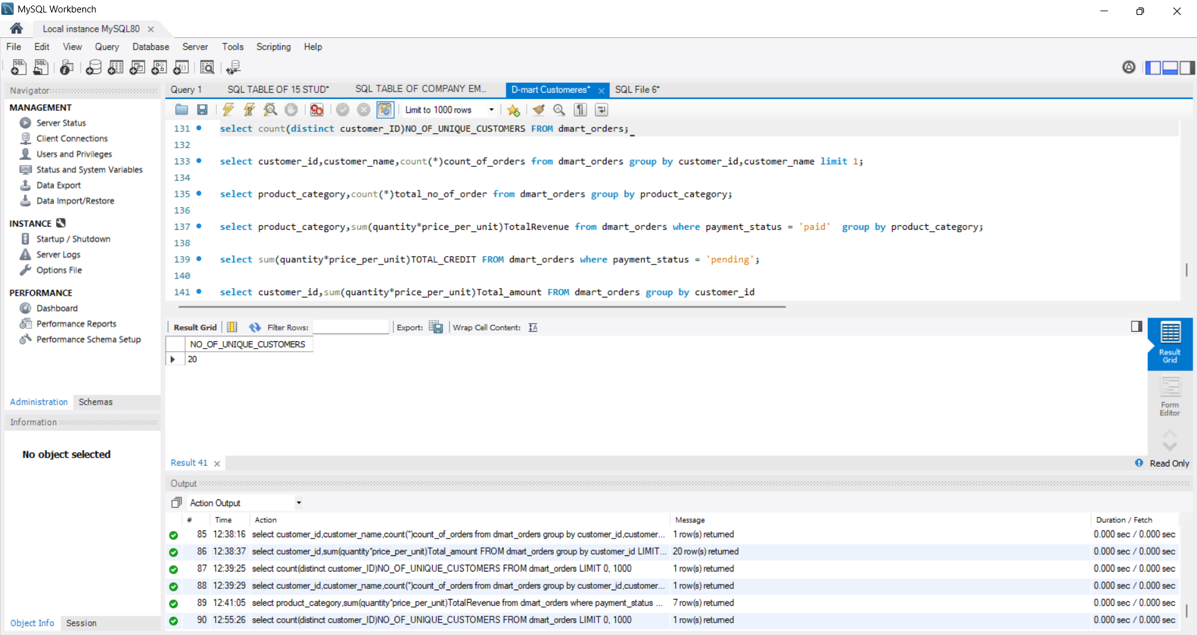

Insight:
20 customers ordered unique items between 1 jan 2026 to 19 feb 2026

Q2. Print customer name with highest number of orders.

QUERY:
select customer_id,customer_name,count(*)count_of_orders from dmart_orders group by customer_id,customer_name limit 1;

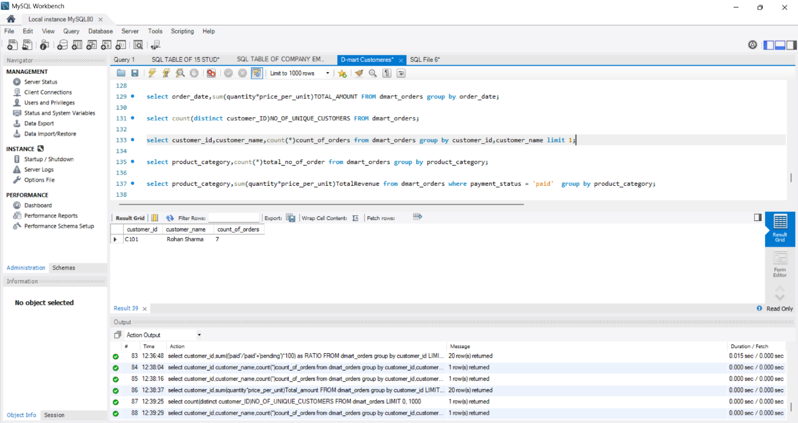

Insights:
Customer Rohan sharma with Customer Id C101 has highest order that is 7

Q3.print number of orders per category

QUERY:
select product_category,count(*)total_no_of_order from dmart_orders group by product_category;

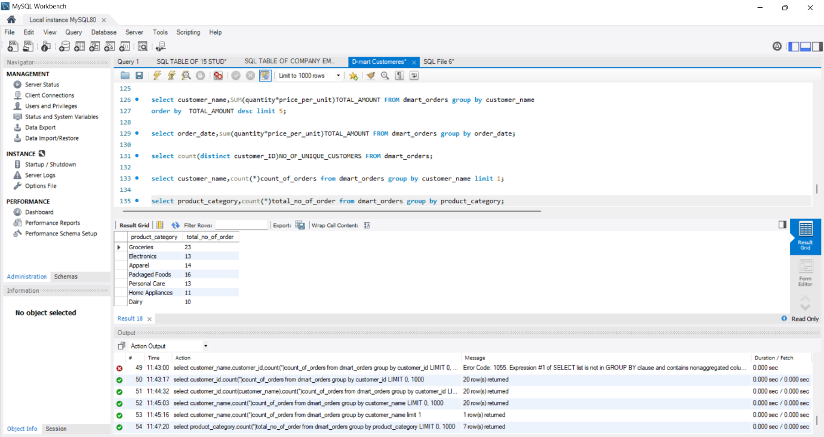

Insights:
Between 1 jan 2026 to 19 feb 2026 best seller category was Groceries with 23 items selled and least selling was Dairy with 10 itmes selled.

Q4.Print category wise revenue

Query:
select product_category,sum(quantity*price_per_unit)TotalRevenue from dmart_orders where payment_status = 'paid' group by product_category;

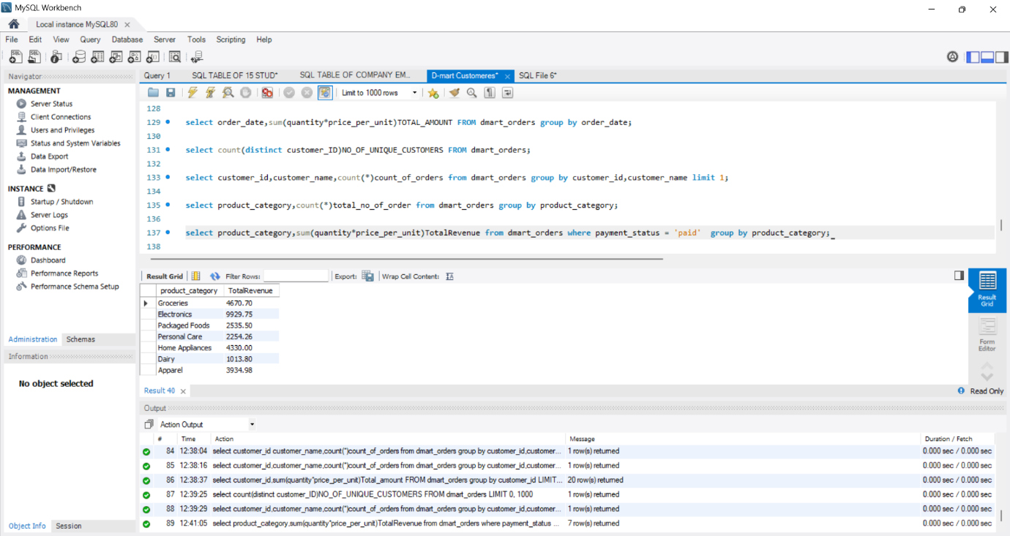

Insight:
In Category wise Revenue between 1 jan 2026 to 19 feb 2026 Groceries generated highest revenue that was 4670.70 and lowest was Apparel that was 3934.98

Q5. Total credit of all the orders

Query:

select sum(quantity*price_per_unit)TOTAL_CREDIT FROM dmart_orders where payment_status = 'pending';

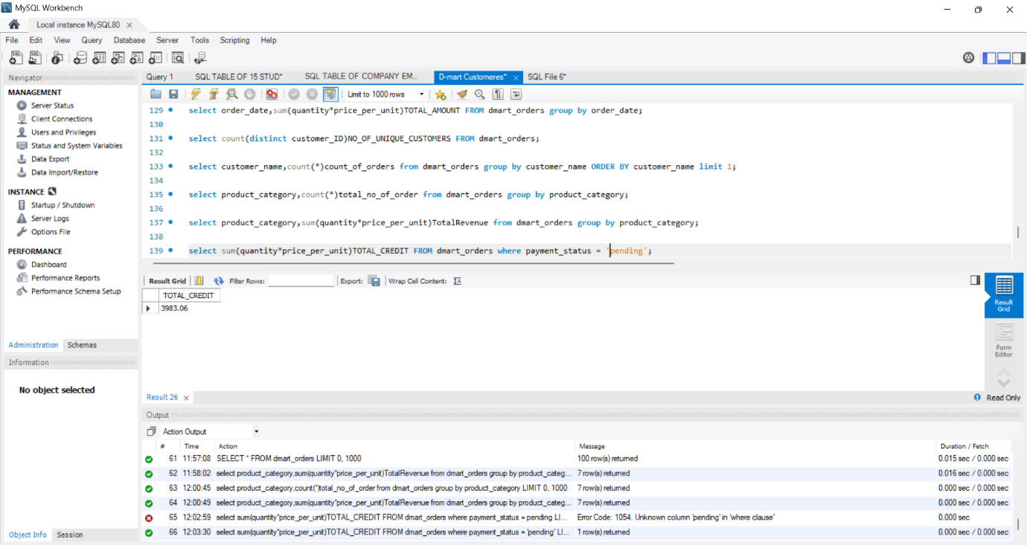

Insights:

Total credit amount between 1 jan 2026 to 19 feb 2026 is : 3983.06

